Hystrix, Retry, and Fault Tolerance
Interview prep guide for resilient distributed systems
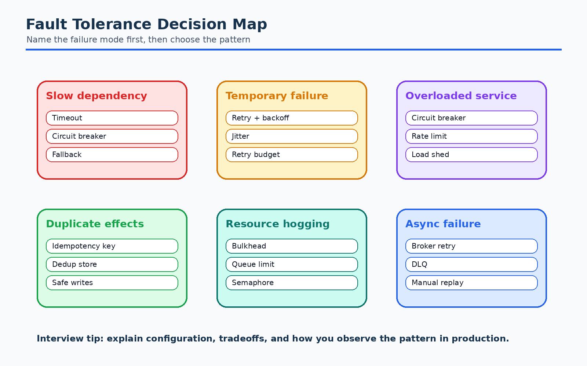
Core Theme  Fault tolerance and retry | Main Patterns  Circuit breaker, fallback, bulkhead, timeout | Interview Focus  Failure modes, tradeoffs, safe retries

This guide is a comprehensive interview-prep reference for Hystrix, retries,
circuit breakers, and fault tolerance in distributed systems.
Hystrix itself is no longer actively developed by Netflix, but it remains an
important interview topic because it popularized many resilience patterns used
today. Modern systems often use Resilience4j, Sentinel, Envoy, service mesh
policies, cloud load balancer policies, or framework-native resilience tools,
but the concepts are the same.

Table of Contents
- [Why Fault Tolerance Matters](#why-fault-tolerance-matters)
- [What Is Hystrix?](#what-is-hystrix)
- [Core Problems Hystrix Solves](#core-problems-hystrix-solves)
- [Important Hystrix Concepts](#important-hystrix-concepts)
- [Circuit Breaker Pattern](#circuit-breaker-pattern)
- [Fallback Pattern](#fallback-pattern)
- [Timeout Pattern](#timeout-pattern)
- [Bulkhead Pattern](#bulkhead-pattern)
- [Retry Pattern](#retry-pattern)
- [Retry Possibilities and Strategies](#retry-possibilities-and-strategies)
- [Retry Anti-patterns](#retry-anti-patterns)
- [Combining Timeout, Retry, Circuit Breaker, and Bulkhead](#combining-timeout-retry-circuit-breaker-and-bulkhead)
- [Idempotency and Retry Safety](#idempotency-and-retry-safety)
- [Real-life E-commerce Examples](#real-life-e-commerce-examples)
- [Hystrix Configuration Cheat Sheet](#hystrix-configuration-cheat-sheet)
- [Hystrix vs Resilience4j](#hystrix-vs-resilience4j)
- [Observability and Metrics](#observability-and-metrics)
- [Common Interview Questions](#common-interview-questions)
- [Quick Revision Notes](#quick-revision-notes)

Why Fault Tolerance Matters
In a monolith, many operations happen inside one process. In microservices,
a single user request may call many services:
Checkout API
-> Order Service
-> Payment Service
-> Inventory Service
-> Shipping Service
-> Notification Service
Every network call can fail because of:
- Service crash
- Slow response
- Network timeout
- DNS issue
- Deployment restart
- Database slowness
- Thread pool exhaustion
- Traffic spike
- Bad release
- Cloud zone outage
Fault tolerance means designing the system so failures are expected, isolated,
and handled gracefully.
The main goal is not to prevent every failure. That is impossible. The main goal
is to prevent one failure from taking down the entire system.

Key fault-tolerance goals
- Fail fast
- Do not wait forever for a broken dependency.
- Isolate failures
- A failing payment provider should not exhaust all checkout threads.
- Degrade gracefully
- If recommendations fail, still show the product page.
- Recover automatically
- Retry transient failures carefully.
- Protect downstream systems
- Do not retry aggressively into an already overloaded service.
- Preserve user experience
- Return a useful response, fallback, queued status, or clear error.

What Is Hystrix?
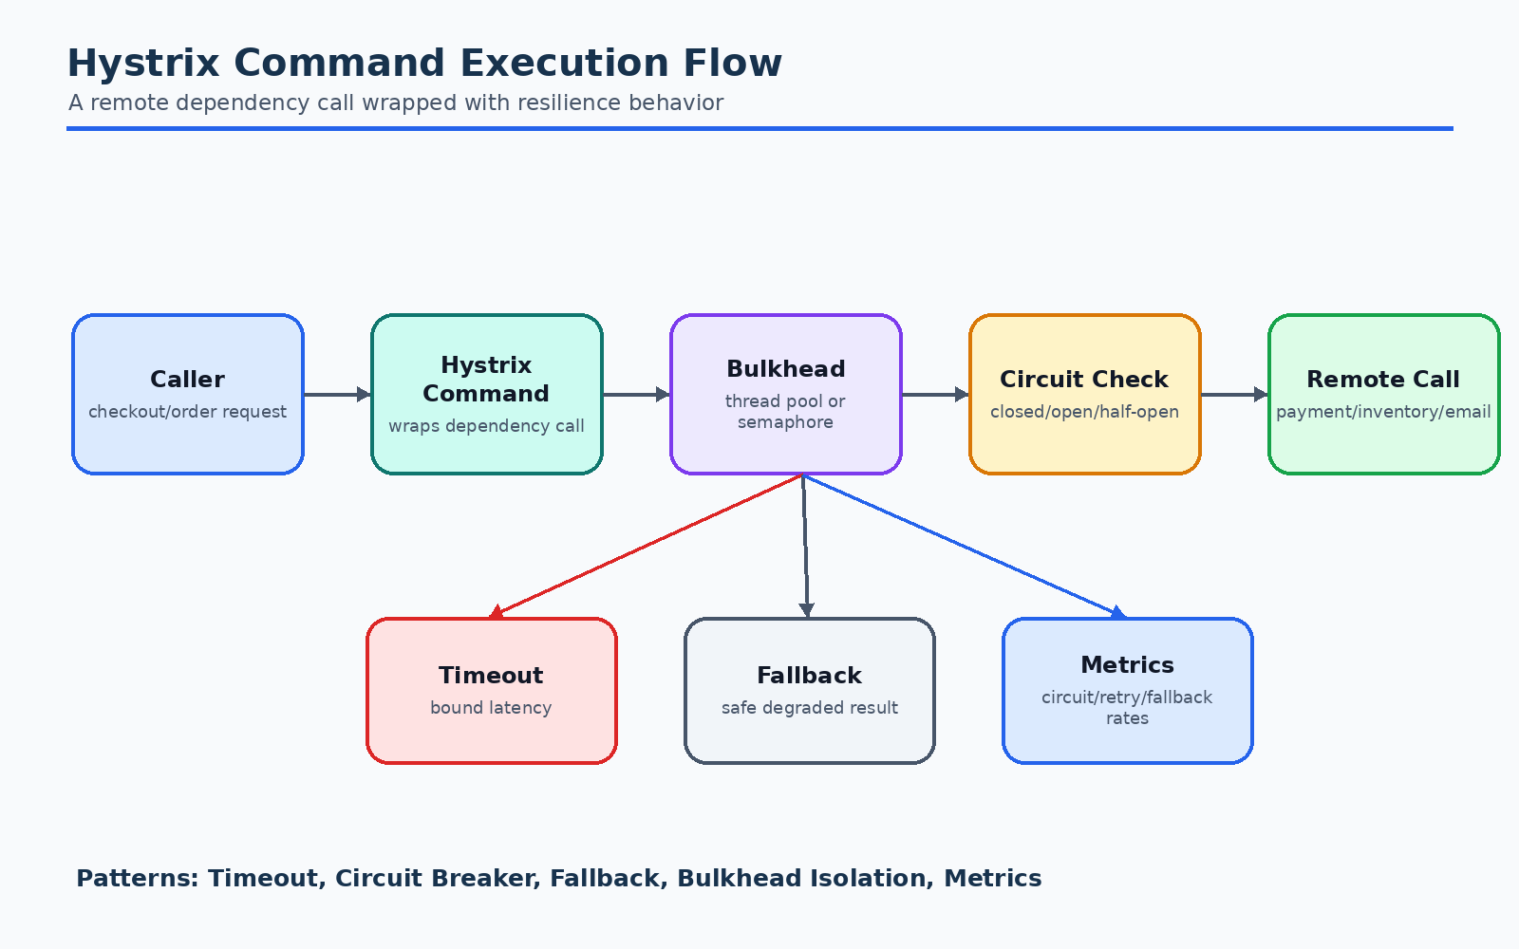
Diagram: What Is Hystrix?
Hystrix is a Netflix library designed to make distributed systems more resilient.
It wraps calls to remote services, databases, caches, or other dependencies and
adds fault-tolerance behavior.
Hystrix provides:
- Circuit breaker
- Timeout
- Fallback
- Bulkhead isolation with thread pools or semaphores
- Request caching
- Request collapsing
- Metrics and dashboard support
Hystrix is commonly explained as a library that prevents cascading failures.

Simple Hystrix mental model
Without Hystrix:
Order Service -> Payment Service
If Payment Service becomes slow, Order Service threads wait. If enough threads
wait, Order Service also becomes slow or unavailable.
With Hystrix:
Order Service -> Hystrix Command -> Payment Service
|
+-> timeout
+-> circuit breaker
+-> fallback
+-> isolated thread pool
Hystrix controls how the dependency call behaves.

Core Problems Hystrix Solves

1. Cascading failure
A cascading failure happens when one failing service causes other services to
fail.
Example:
Payment Service slow
-> Order Service threads blocked
-> Checkout API waiting
-> API Gateway queues requests
-> Entire checkout path becomes unavailable
Hystrix helps by adding timeouts, circuit breakers, and isolation.

2. Thread pool exhaustion
If a service uses the same thread pool for all downstream calls, one slow
dependency can consume all threads.
Example:
100 web request threads
90 blocked on Payment Service
10 left for everything else
Hystrix can isolate dependencies with separate thread pools.

3. Slow dependency
A dependency may not fail immediately. It may become slow.
Slow failure is often worse than fast failure because resources remain occupied.
Hystrix timeouts prevent long waits.

4. Repeated calls to known-bad dependency
If a dependency is clearly unhealthy, continuing to call it wastes resources.
Hystrix circuit breaker opens and fails fast.

5. No fallback behavior
Without fallback, every dependency failure becomes a user-visible error.
Hystrix supports fallback responses.

Important Hystrix Concepts

HystrixCommand
HystrixCommand wraps a dependency call.
Conceptually:
class GetPaymentStatusCommand extends HystrixCommand<PaymentStatus> {
protected PaymentStatus run() {
return paymentClient.getStatus(orderId);
}
protected PaymentStatus getFallback() {
return PaymentStatus.UNKNOWN;
}
}
The run() method contains the real remote call.
The getFallback() method contains fallback behavior.

Command key
The command key identifies a command type.
Example:
GetPaymentStatus
AuthorizePayment
ReserveInventory
Metrics are usually grouped by command key.

Group key
The group key groups related commands.
Example:
PaymentGroup
InventoryGroup
ShippingGroup

Thread pool key
The thread pool key identifies the thread pool used for isolation.
Example:
PaymentThreadPool
InventoryThreadPool
ShippingThreadPool

Execution isolation
Hystrix can isolate dependency calls using:
- Thread isolation
- Semaphore isolation
Thread isolation is more common for remote calls. Semaphore isolation is useful
for very low-latency in-process calls where thread switching overhead is not
desired.

Circuit Breaker Pattern
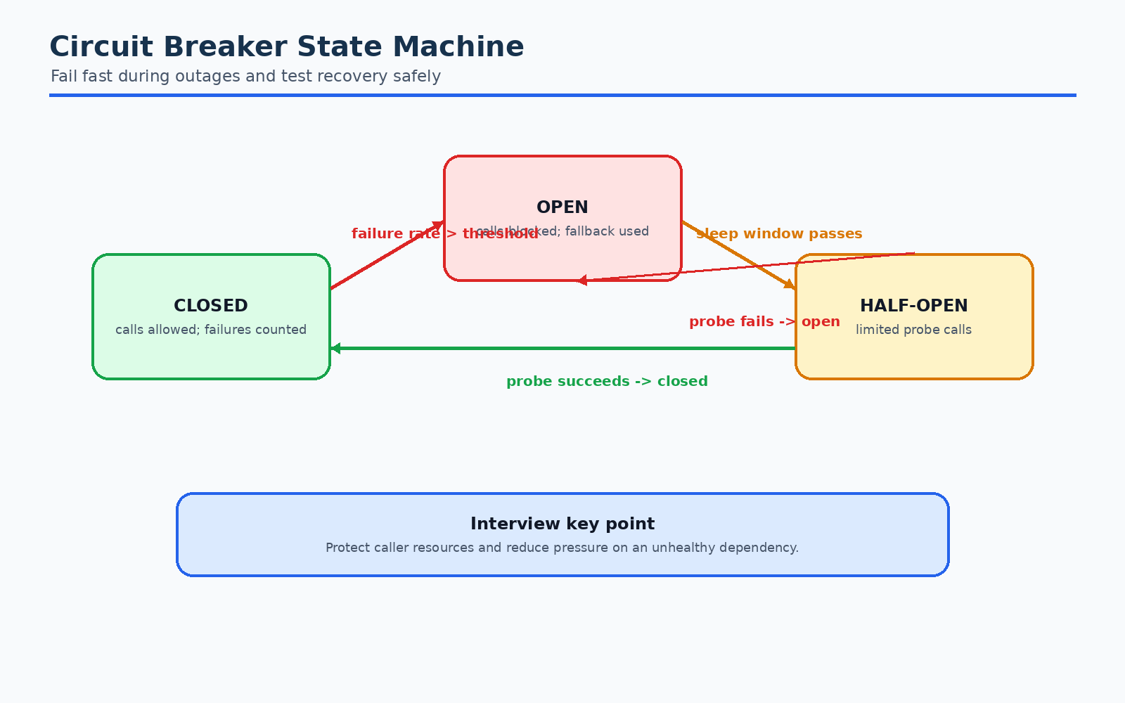
Diagram: Circuit Breaker Pattern
The circuit breaker is one of the most important fault-tolerance patterns.
It works like an electrical circuit breaker. If too many calls fail, the circuit
opens and calls are blocked temporarily.

Circuit breaker states
CLOSED -> OPEN -> HALF_OPEN -> CLOSED

CLOSED state
The dependency is considered healthy.
Calls are allowed.
Failures are counted.
Order Service -> Payment Service
If failure rate crosses a threshold, circuit opens.

OPEN state
The dependency is considered unhealthy.
Calls are not sent to the dependency.
Requests fail fast or go to fallback.
Order Service -> fallback
This protects both caller and callee.

HALF_OPEN state
After a sleep window, the circuit allows a small number of test calls.
If test calls succeed, circuit closes.
If test calls fail, circuit opens again.

Circuit breaker timeline
Normal traffic
|
v
Failures increase
|
v
Failure threshold exceeded
|
v
Circuit OPEN: fail fast
|
v
Sleep window passes
|
v
Circuit HALF_OPEN: allow test request
|
+-- success -> CLOSED
|
+-- failure -> OPEN

When should circuit breaker open?
Common conditions:
- Failure rate exceeds threshold.
- Timeout rate exceeds threshold.
- Rejected calls exceed threshold.
- Minimum request volume reached.
Example:
If at least 20 requests happened in the last 10 seconds
and more than 50% failed,
open the circuit for 5 seconds.
Minimum request volume is important. Without it, 1 failure out of 1 request
would look like 100% failure.

Interview answer
Circuit breaker prevents repeated calls to an unhealthy dependency. It protects
the caller from waiting and protects the downstream service from being flooded
while it is already unhealthy.

Fallback Pattern
Fallback is an alternative response when the main call fails.
Fallback can happen because of:
- Timeout
- Exception
- Circuit open
- Thread pool rejection
- Semaphore rejection

Examples of fallback

Product recommendation fallback
If recommendation service fails:
Return popular products instead of personalized recommendations.
This is a good fallback.

Payment authorization fallback
If payment authorization fails:
Do not assume payment succeeded.
Return payment pending or payment failed.
This must be handled carefully.

Inventory fallback
If inventory service fails:
Do not promise stock is available.
Return "availability unknown" or prevent checkout.
Fallback should not lie.

Good fallback characteristics
Good fallback is:
- Safe
- Fast
- Local or cached
- Business-acceptable
- Observable

Bad fallback examples
Bad:
Payment service failed, so mark payment successful.
Bad:
Inventory failed, so assume item is available.
Bad:
Fallback calls another slow remote service without protection.

Fallback can also fail
Fallback logic should be simple. If fallback also depends on remote calls, it can
fail and create more problems.
Preferred fallback sources:
- Static default value
- Local cache
- Precomputed data
- Graceful error response
- Queue for later processing

Timeout Pattern
Timeout controls how long the caller waits for a dependency.
Without timeout, a thread can wait indefinitely.

Why timeouts are critical
If the user request budget is 2 seconds, a downstream call should not wait 10
seconds.
Example:
API Gateway timeout: 2 seconds
Order Service total budget: 1.5 seconds
Payment timeout: 500 ms
Inventory timeout: 500 ms
Shipping estimate timeout: 300 ms
Timeouts should be designed from the outside in.

Timeout vs retry
Retry increases total time unless carefully controlled.
If timeout is 1 second and retry count is 3, worst-case time may be 3 seconds
plus backoff delays.

Interview answer
Timeouts prevent resource exhaustion caused by slow dependencies. They should be
smaller than the caller's overall request deadline and coordinated with retry
budgets.

Bulkhead Pattern
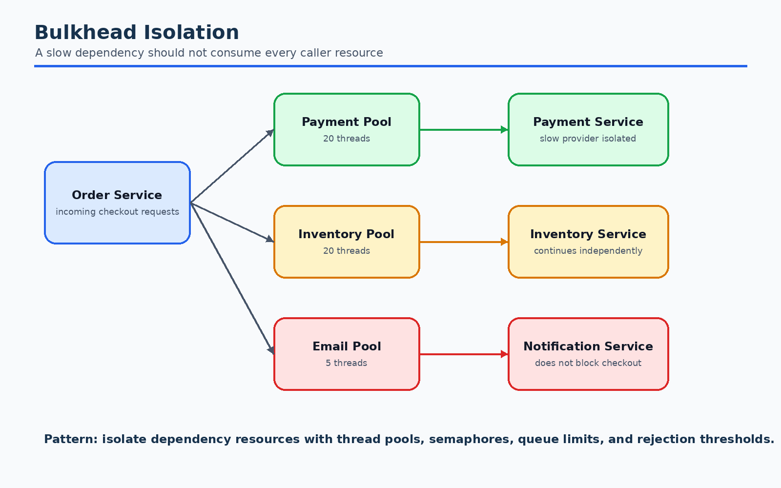
Diagram: Bulkhead Pattern
Bulkhead isolates resources so failure in one area does not sink the whole
system.
The pattern comes from ships. A ship has compartments. If one compartment
floods, the whole ship does not sink.

Thread pool bulkhead
Each dependency gets a separate thread pool.
Order Service
Payment thread pool: 20 threads
Inventory thread pool: 20 threads
Shipping thread pool: 10 threads
Recommendation thread pool: 5 threads
If Recommendation Service is slow, it only exhausts recommendation threads.
Payment and inventory can continue.

Semaphore bulkhead
Semaphore isolation limits concurrent calls without using separate threads.
Example:
Max 50 concurrent calls to cache lookup

Thread isolation vs semaphore isolation
Isolation type | Best for | Pros | Cons
Thread pool | Remote network calls | Strong isolation, timeout support | Thread overhead
Semaphore | Fast local calls | Lightweight | Weaker isolation

Interview answer
Bulkhead prevents one failing dependency from consuming all shared resources.
Hystrix implements this with thread pool or semaphore isolation.

Retry Pattern
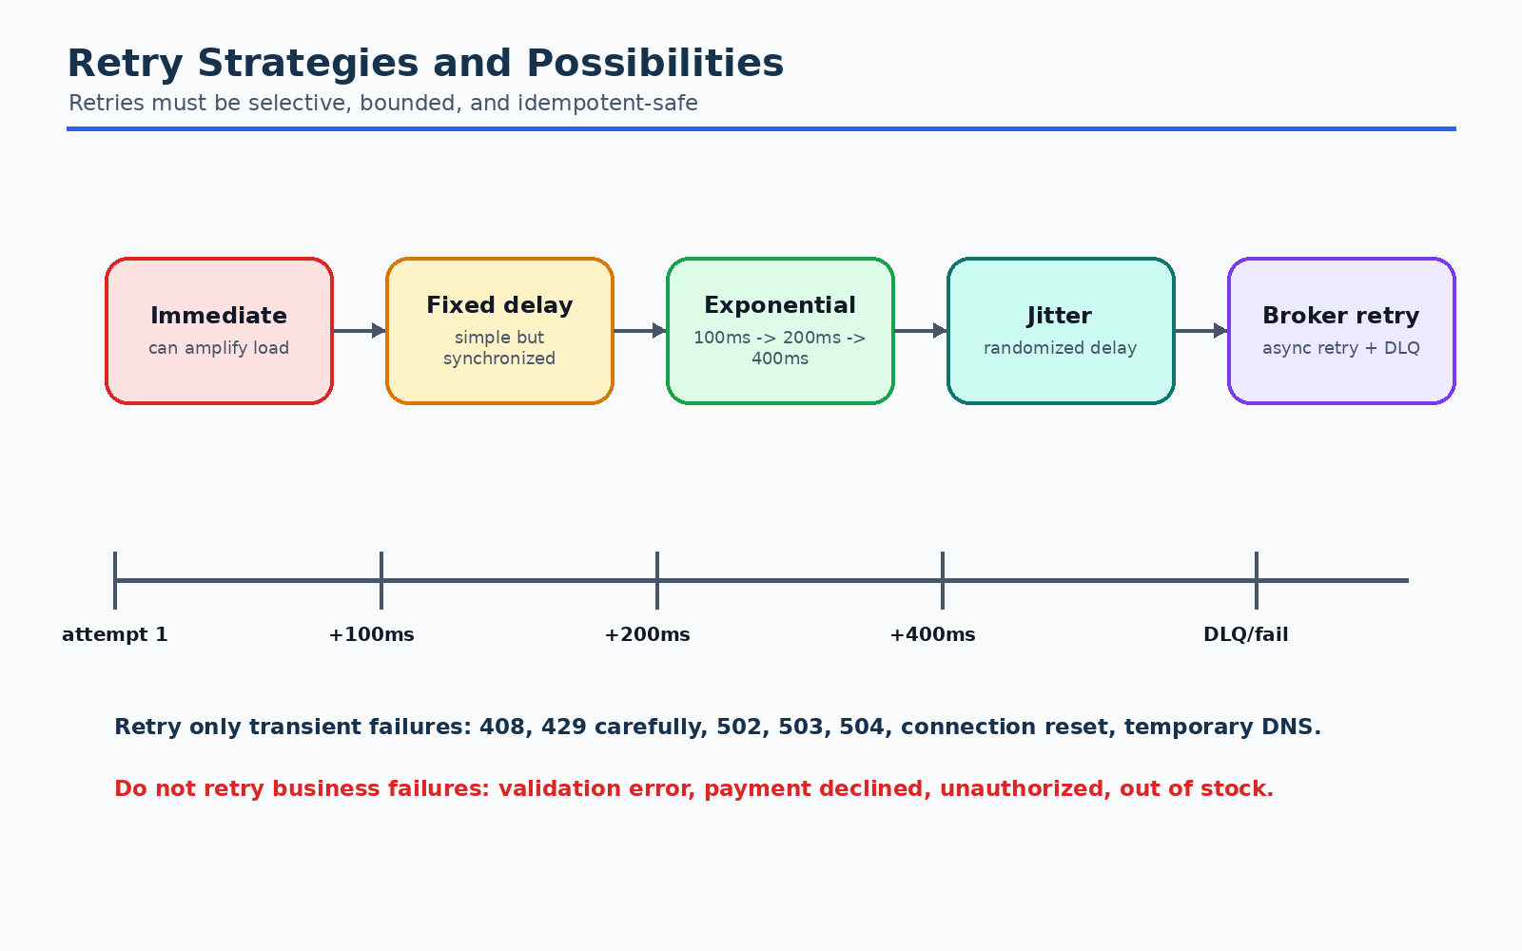
Diagram: Retry Pattern
Retry means trying an operation again after failure.
Retry is useful for transient failures:
- Temporary network glitch
- Connection reset
- HTTP 503
- Temporary lock timeout
- Rate-limited dependency, if retry-after is respected
- Leader election or failover
Retry is dangerous for persistent failures:
- Bad request
- Invalid card
- Insufficient funds
- Item permanently out of stock
- Authentication failure
- Schema mismatch

Simple retry
Try request
If failure, try again immediately
This is usually not recommended because immediate retries can overload a
struggling service.

Retry with fixed delay
Try request
Wait 100 ms
Retry
Wait 100 ms
Retry
Simple, but many clients can synchronize and retry at the same time.

Retry with exponential backoff
Retry 1 after 100 ms
Retry 2 after 200 ms
Retry 3 after 400 ms
Retry 4 after 800 ms
This gives the dependency time to recover.

Retry with jitter
Jitter adds randomness to retry delay.
Retry delay = random between 100 ms and 400 ms
Jitter prevents retry storms where many clients retry simultaneously.

Retry with max elapsed time
Instead of only retry count, set a total time budget.
Example:
Max attempts: 3
Max elapsed time: 800 ms
This prevents retries from exceeding user request deadlines.

Retry with Retry-After
If server returns:
HTTP 429 Too Many Requests
Retry-After: 5
The client should wait as instructed, if the request deadline allows it.

Retry only certain failures
Retry should be selective.
Retry:
- HTTP 408 Request Timeout
- HTTP 429 Too Many Requests, carefully
- HTTP 500, sometimes
- HTTP 502 Bad Gateway
- HTTP 503 Service Unavailable
- HTTP 504 Gateway Timeout
- Connection reset
- Temporary DNS failure
Do not retry:
- HTTP 400 Bad Request
- HTTP 401 Unauthorized
- HTTP 403 Forbidden
- HTTP 404 Not Found, usually
- Business validation errors
- Payment declined
- Insufficient funds
- Out of stock

Retry Possibilities and Strategies

Diagram: Retry Possibilities and Strategies

1. Client-side retry
The caller retries the dependency call.
Example:
Order Service retries Payment Service call.
Pros:
- Simple
- Caller controls user request deadline
Cons:
- Many callers can overload dependency
- Retry logic duplicated across clients

2. Server-side retry
The receiving service retries its own downstream dependency.
Example:
Payment Service retries external payment gateway.
Pros:
- Keeps gateway retry logic inside Payment Service
- Easier to centralize provider-specific rules
Cons:
- Caller may not know how long it will take
- Can still create hidden latency

3. Broker-based retry
For asynchronous processing, failed messages are retried by queue/broker
mechanisms.
Example:
OrderConfirmed event -> Notification Service fails
Message retried after delay
After max attempts -> DLQ
Pros:
- Good for background work
- Durable retries
- Does not block user request
Cons:
- Eventual consistency
- Operational DLQ handling required

4. Scheduled retry
A job scans failed or pending records and retries later.
Example:
Retry payment capture every 5 minutes for pending payments.
Pros:
- Useful for long-running business processes
- Easy to inspect state in database
Cons:
- Slower recovery
- Requires careful locking and deduplication

5. Manual retry
Operations team or admin retries failed business actions.
Example:
Support agent retries refund after payment gateway outage.
Pros:
- Good for sensitive operations
- Human review before side effects
Cons:
- Slower
- Requires tooling and audit trail

6. Hedged requests
Send a duplicate request to another replica after a small delay, and use the
first successful response.
Example:
Call inventory replica A
If no response after 80 ms, call replica B
Use first success
Pros:
- Reduces tail latency
Cons:
- Increases load
- Must be safe and idempotent
Usually used for reads, not writes.

7. Retry budget
A retry budget limits how many retries are allowed relative to real traffic.
Example:
Retries must not exceed 10% of normal request volume.
Pros:
- Prevents retries from overwhelming systems
- Useful at scale
Cons:
- Requires metrics and enforcement

Retry Anti-patterns

Anti-pattern 1: Retrying non-idempotent operations blindly
Example:
POST /charge-card
timeout happens
retry creates duplicate charge
Fix:
- Use idempotency keys.
- Make payment operation idempotent by order ID or payment request ID.

Anti-pattern 2: Infinite retries
Infinite retries can overload dependencies forever.
Fix:
- Set max attempts.
- Set max elapsed time.
- Use DLQ or manual review.

Anti-pattern 3: Retry storm
When a service recovers, thousands of clients retry simultaneously.
Fix:
- Exponential backoff.
- Jitter.
- Retry budget.
- Circuit breaker.

Anti-pattern 4: Retrying through multiple layers
Example:
API Gateway retries 3 times
Order Service retries 3 times
Payment SDK retries 3 times
Payment gateway client retries 3 times
Total possible attempts:
3 x 3 x 3 x 3 = 81 attempts
Fix:
- Coordinate retries across layers.
- Prefer one responsible retry layer.
- Use deadlines.

Anti-pattern 5: Retry after timeout without cancellation
If the original request is still running and the caller retries, both attempts
may execute.
Fix:
- Use cancellation where possible.
- Use idempotency keys.
- Keep server-side operations safe.

Combining Timeout, Retry, Circuit Breaker, and Bulkhead

Diagram: Combining Timeout, Retry, Circuit Breaker, and Bulkhead
These patterns are often used together.
Recommended order:
Caller
-> bulkhead isolation
-> circuit breaker permission check
-> timeout
-> retry policy, if safe
-> fallback, if needed
In practice, frameworks may order these differently. The design goal is:
- Limit concurrency.
- Avoid calls when dependency is unhealthy.
- Bound latency.
- Retry only safe transient failures.
- Fallback safely.

Example: Payment authorization
Payment authorization is sensitive because duplicate charges are unacceptable.
Recommended:
- Timeout: yes
- Circuit breaker: yes
- Bulkhead: yes
- Retry: maybe, only with idempotency key
- Fallback: payment pending or payment failed, never payment success
Order Service -> Payment Service
timeout: 800 ms
max retries: 1
idempotency key: orderId + paymentAttemptId
circuit breaker opens at 50% failures
fallback: mark payment as PENDING_REVIEW

Example: Product recommendation
Recommendation failure should not block product page.
Recommended:
- Timeout: yes, very short
- Circuit breaker: yes
- Bulkhead: yes, small pool
- Retry: usually no for user request path
- Fallback: popular products

Example: Notification
Notification is usually asynchronous.
Recommended:
- Timeout: yes
- Retry: yes with backoff
- Circuit breaker: yes for provider
- Bulkhead: yes per provider/channel
- Fallback: try alternate channel or DLQ

Idempotency and Retry Safety
Idempotency means the same operation can be performed multiple times and the
final result remains correct.

Naturally idempotent examples
GET /orders/ORD-123
PUT /orders/ORD-123/status/CANCELLED
DELETE /cart/items/SKU-1

Not naturally idempotent examples
POST /payments/charge
POST /shipments
POST /send-email
These can create duplicate side effects.

Idempotency key
An idempotency key uniquely identifies a logical operation.
Example:
Idempotency-Key: order-ORD-123-payment-attempt-1
Payment Service stores:
idempotency_key
request_hash
result
created_at
If the same key is received again, return the previous result.

Interview answer
Retries are safe only when the operation is idempotent or protected by an
idempotency key. Without idempotency, retries can create duplicate payments,
duplicate shipments, duplicate emails, or inconsistent state.

Real-life E-commerce Examples

Example 1: Checkout payment provider outage
Problem:
Payment provider becomes slow during a sale.
Risk:
- Checkout threads block.
- Users retry manually.
- Payment provider receives more traffic.
- Order Service becomes unavailable.
Fault-tolerance design:
- Payment calls use a dedicated bulkhead.
- Payment calls have strict timeout.
- Circuit breaker opens when failures cross threshold.
- Retry only once and only with idempotency key.
- Fallback marks payment as pending or asks user to retry later.
Patterns used:
- Circuit Breaker
- Timeout
- Bulkhead
- Retry with Backoff
- Idempotency Key
- Fallback

Example 2: Inventory service intermittent failure
Problem:
Inventory Service occasionally returns 503.
Design:
- Retry 1 or 2 times with short exponential backoff.
- Use circuit breaker for sustained failures.
- If still failing, do not confirm order.
- Mark order as awaiting inventory or cancel depending on business policy.
Patterns used:
- Retry
- Circuit Breaker
- Saga
- Fallback

Example 3: Email provider down
Problem:
Order is confirmed, but email provider is down.
Design:
- Do not fail order confirmation.
- Queue notification event.
- Retry with backoff.
- Move to DLQ after max attempts.
- Alert operations.
- Optionally try SMS/push fallback.
Patterns used:
- Asynchronous Retry
- DLQ
- Bulkhead
- Circuit Breaker
- Fallback Channel

Example 4: Product recommendation timeout
Problem:
Recommendation Service is slow.
Design:
- Timeout after 100 ms.
- Circuit breaker opens quickly.
- Fallback to popular products.
- Do not retry in request path.
Patterns used:
- Timeout
- Circuit Breaker
- Fallback
- Bulkhead

Hystrix Configuration Cheat Sheet
Common Hystrix configuration categories:

Circuit breaker config
circuitBreaker.enabled=true
circuitBreaker.requestVolumeThreshold=20
circuitBreaker.errorThresholdPercentage=50
circuitBreaker.sleepWindowInMilliseconds=5000
Meaning:
- At least 20 requests must happen before judging failure percentage.
- If 50% fail, circuit opens.
- After 5 seconds, circuit tries half-open test.

Timeout config
execution.timeout.enabled=true
execution.isolation.thread.timeoutInMilliseconds=1000
Meaning:
- Command times out after 1 second.

Thread pool config
threadPool.coreSize=20
threadPool.maxQueueSize=50
threadPool.queueSizeRejectionThreshold=40
Meaning:
- 20 threads for this dependency.
- Queue up to configured limit.
- Reject when queue threshold is crossed.

Semaphore config
execution.isolation.strategy=SEMAPHORE
execution.isolation.semaphore.maxConcurrentRequests=50
Meaning:
- Allow at most 50 concurrent calls.

Fallback semaphore config
fallback.isolation.semaphore.maxConcurrentRequests=10
Meaning:
- Limit concurrent fallback executions.

Important tuning advice
Do not copy values blindly. Tune based on:
- Dependency latency
- Traffic volume
- Error rate
- User request timeout
- Thread capacity
- Business criticality

Hystrix vs Resilience4j
Hystrix is in maintenance mode and no longer actively developed.
Resilience4j is a modern lightweight Java fault-tolerance library.
Capability | Hystrix | Resilience4j
Circuit breaker | Yes | Yes
Retry | Limited / separate patterns | Yes
Rate limiter | No native core equivalent | Yes
Bulkhead | Thread/semaphore | Semaphore/thread-pool bulkhead
Time limiter | Timeout | TimeLimiter
Functional style | Older command style | Decorators/functions
Project status | Maintenance mode | Actively used

Interview wording
If asked about Hystrix today:
> Hystrix popularized circuit breakers, fallbacks, and bulkhead isolation. In
> modern Java systems I would usually use Resilience4j or service mesh features,
> but the same resilience principles apply.

Observability and Metrics
Fault tolerance without observability is dangerous.
You need to monitor:
- Request rate
- Success count
- Failure count
- Timeout count
- Rejection count
- Fallback count
- Circuit breaker open/close state
- Thread pool saturation
- Queue depth
- Retry count
- Retry success rate
- DLQ count
- Latency percentiles

Important alerts
Alert on:
- Circuit open for critical dependency
- High fallback rate
- Thread pool near saturation
- Retry volume spike
- DLQ messages increasing
- P99 latency increase
- Error budget burn

Why fallback metrics matter
If fallback hides errors from users, the system may look healthy while business
quality is degraded.
Example:
Product page loads successfully, but recommendations are always fallback popular
products. This is degraded behavior and should be visible.

Common Interview Questions

1. What is Hystrix?
Hystrix is a fault-tolerance library from Netflix that wraps remote calls and
provides circuit breaker, timeout, fallback, bulkhead isolation, request caching,
and metrics. It helps prevent cascading failures in distributed systems.

2. What problem does circuit breaker solve?
It prevents repeated calls to an unhealthy dependency. When failures cross a
threshold, the circuit opens and calls fail fast or go to fallback. This protects
the caller and gives the dependency time to recover.

3. What are circuit breaker states?
- Closed: calls allowed, failures counted.
- Open: calls blocked, fallback used.
- Half-open: limited test calls allowed to check recovery.

4. What is fallback?
Fallback is an alternate response when the primary call fails, times out, is
rejected, or circuit is open. Fallback must be safe and should not hide critical
business failures incorrectly.

5. What is bulkhead isolation?
Bulkhead isolation separates resources per dependency. If one dependency is slow
or failing, it cannot consume all caller resources.

6. Thread isolation vs semaphore isolation?
Thread isolation uses separate thread pools and gives stronger isolation for
remote calls. Semaphore isolation limits concurrency with less overhead and is
better for fast local operations.

7. When should you retry?
Retry transient failures such as timeout, 503, 502, connection reset, or
temporary rate limiting. Do not retry validation errors, unauthorized requests,
business declines, or permanent failures.

8. Why is retry dangerous?
Retry can amplify traffic, create retry storms, increase latency, and duplicate
side effects if operations are not idempotent.

9. What is exponential backoff with jitter?
Exponential backoff increases delay after each retry. Jitter adds randomness so
many clients do not retry at the same time.

10. What is idempotency key?
An idempotency key identifies a logical operation. If the same request is
received again, the server returns the previous result instead of repeating the
side effect.

11. How do timeout and retry interact?
Retries must fit within the overall request deadline. If each attempt has a long
timeout, retry can exceed the user's acceptable response time.

12. Should fallback call another remote service?
Usually avoid it. Fallback should be simple, fast, and reliable. If it calls
another remote dependency, that call also needs fault tolerance.

13. What is a retry storm?
A retry storm happens when many clients retry a failing service at the same time,
increasing load and making recovery harder.

14. How do you prevent retry storms?
Use exponential backoff, jitter, retry budgets, circuit breakers, rate limiting,
and coordinated retry policies.

15. Why not retry payment blindly?
Payment operations can create duplicate charges. Retry only if protected by
idempotency keys and payment provider semantics.

16. Is Hystrix still used?
Some legacy systems still use it, but Hystrix is no longer actively developed.
Modern systems often use Resilience4j, service mesh policies, or platform
features.

Quick Revision Notes
- Hystrix prevents cascading failures.
- Circuit breaker has closed, open, and half-open states.
- Timeout prevents slow dependencies from exhausting resources.
- Bulkhead isolates dependency resources.
- Fallback provides safe degraded behavior.
- Retry is useful only for transient failures.
- Retry must use max attempts, backoff, jitter, and deadlines.
- Never blindly retry non-idempotent operations.
- Use idempotency keys for payment, shipment, email, and order creation.
- Avoid retries at too many layers.
- Circuit breaker and retry should be coordinated.
- Fallback should not lie about critical business state.
- Monitor fallback rate, circuit state, rejections, retries, and DLQ.
- Hystrix concepts remain important even if modern systems use Resilience4j.

Final Interview Summary
Fault tolerance is about accepting that dependencies fail and designing systems
that remain stable under failure. Hystrix introduced practical patterns for this:
circuit breakers to stop calling unhealthy services, timeouts to bound latency,
bulkheads to isolate resources, and fallbacks to degrade gracefully.
Retry is a separate but related pattern. Retry can recover from transient
failures, but it can also amplify outages and duplicate side effects. Good retry
design requires idempotency, backoff, jitter, max attempts, deadlines, and
observability.
In interviews, always connect these patterns to real production problems:
- Slow payment provider
- Inventory service outage
- Email provider failure
- Recommendation timeout
- Duplicate checkout request
- Thread pool exhaustion
- Retry storm during dependency recovery
The strongest answer is not "use Hystrix". The strongest answer is to explain
which failure mode you are handling, which resilience pattern you choose, how it
is configured, and what tradeoff it introduces.

